# Education quality

Education is a very subjective topic for research. We cannot evaluate education system by one exam all over the world. Additionally, it is nearly impossible to find a full dataset having ALL records, because some countries even do not count the population properly, so the data is never 100% accurate. However, we still tried to show the past and current situations, and predict what will happen if we do nothing.

Why this SDG is related to the project? - Education is the start of everything. People need to learn how to live in the new world with projects like Ecovillage.

## Changes of amount of literate population in the world

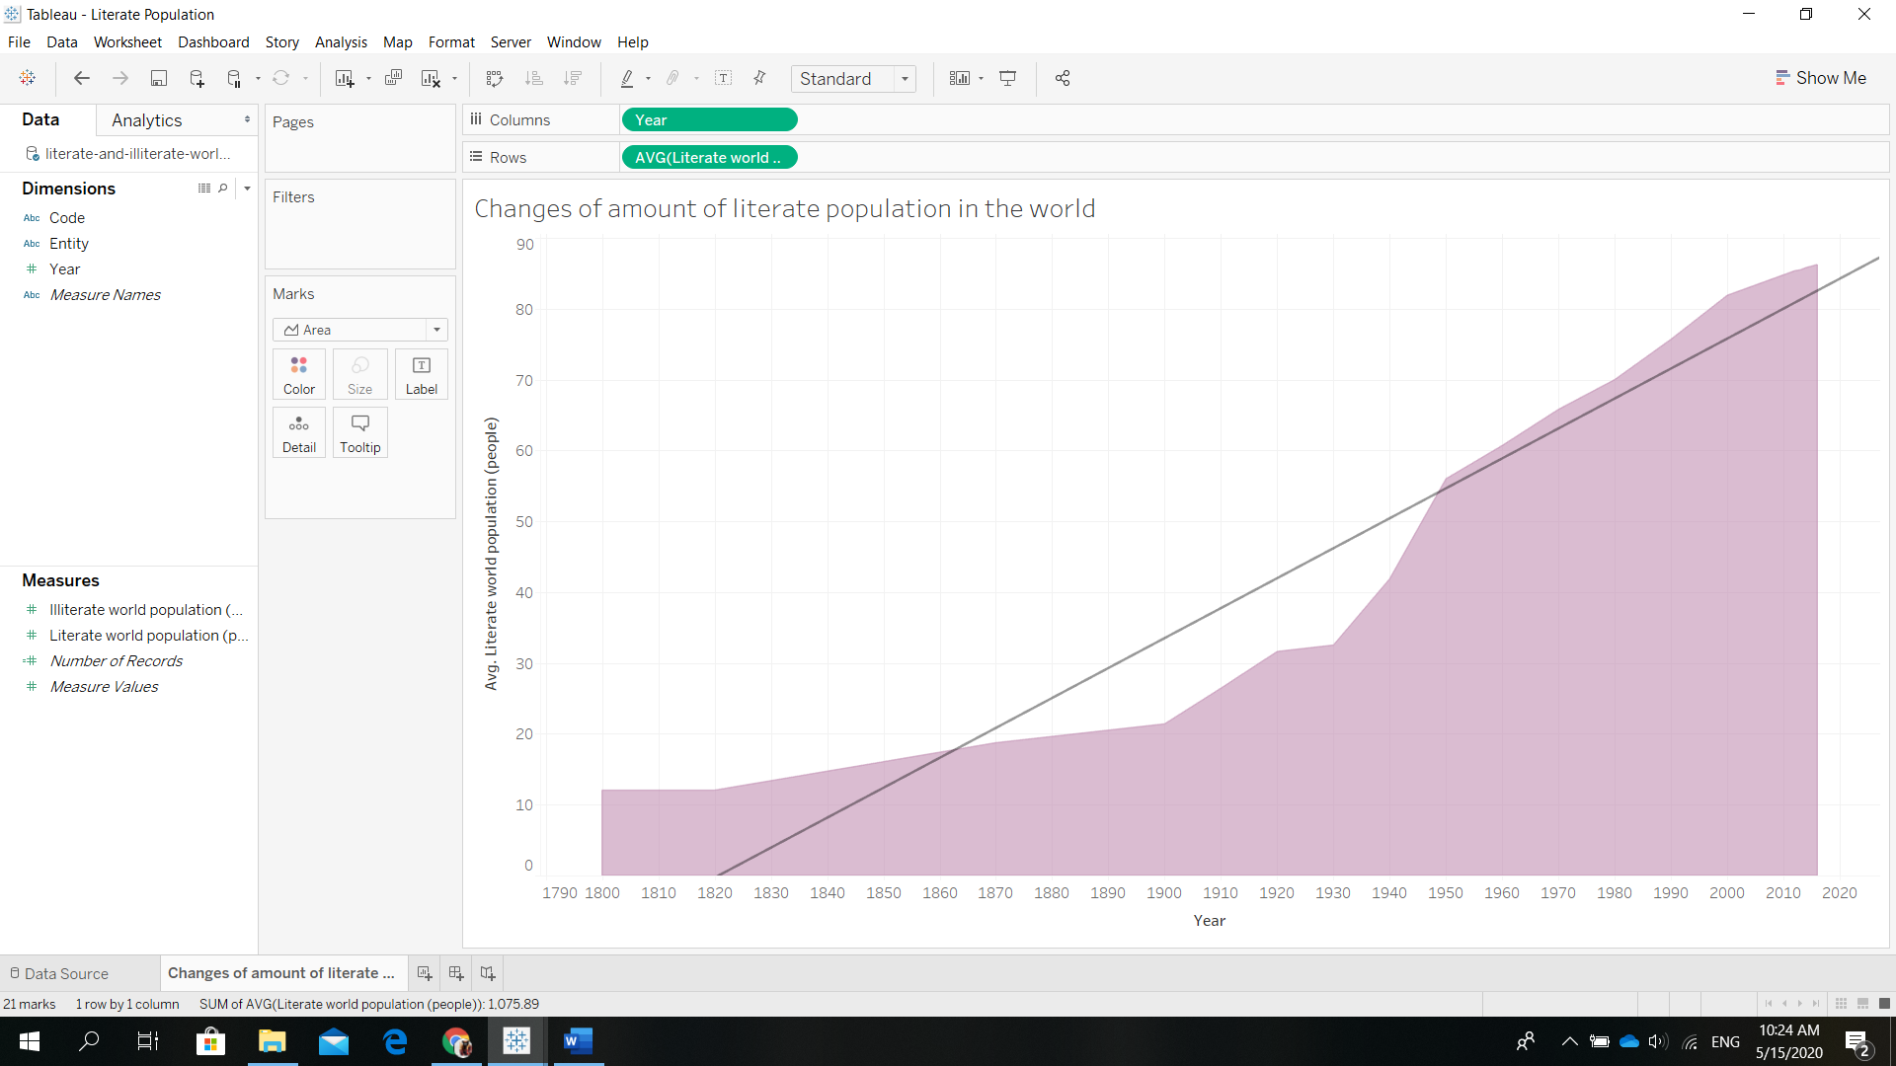

Despite the constant growth of the graph we can see that there were few drop points. We can assume that the reasons were the wars (the 1st and 2nd World Wars). Nowadays the situation is much better. However, by having a better look we might notice that the growth is becoming slightly slower after 2000. If we make a trend line on the graph using the data only after 2000 we will see a different picture:

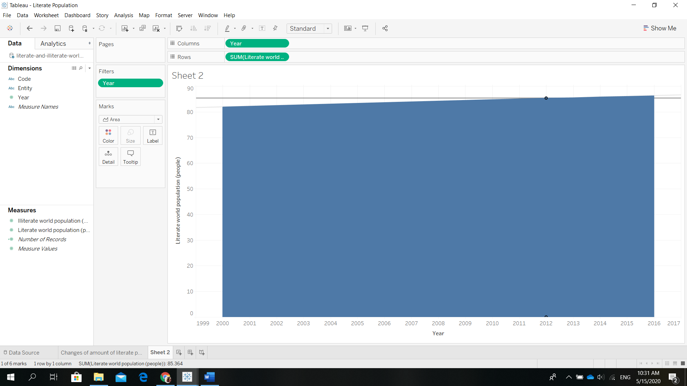

A trend line shows that the growth almost stopped.

Why this happened?

There might be few reasons:

* Education quality
* Education price
* High level of corruption
* Pressure on students (and teachers)
* High emphasis on grades

All this complains are mentioned on Quora, where people can share their opinions. Those problems are found in mostly developing countries.

## Primary school Enrollment

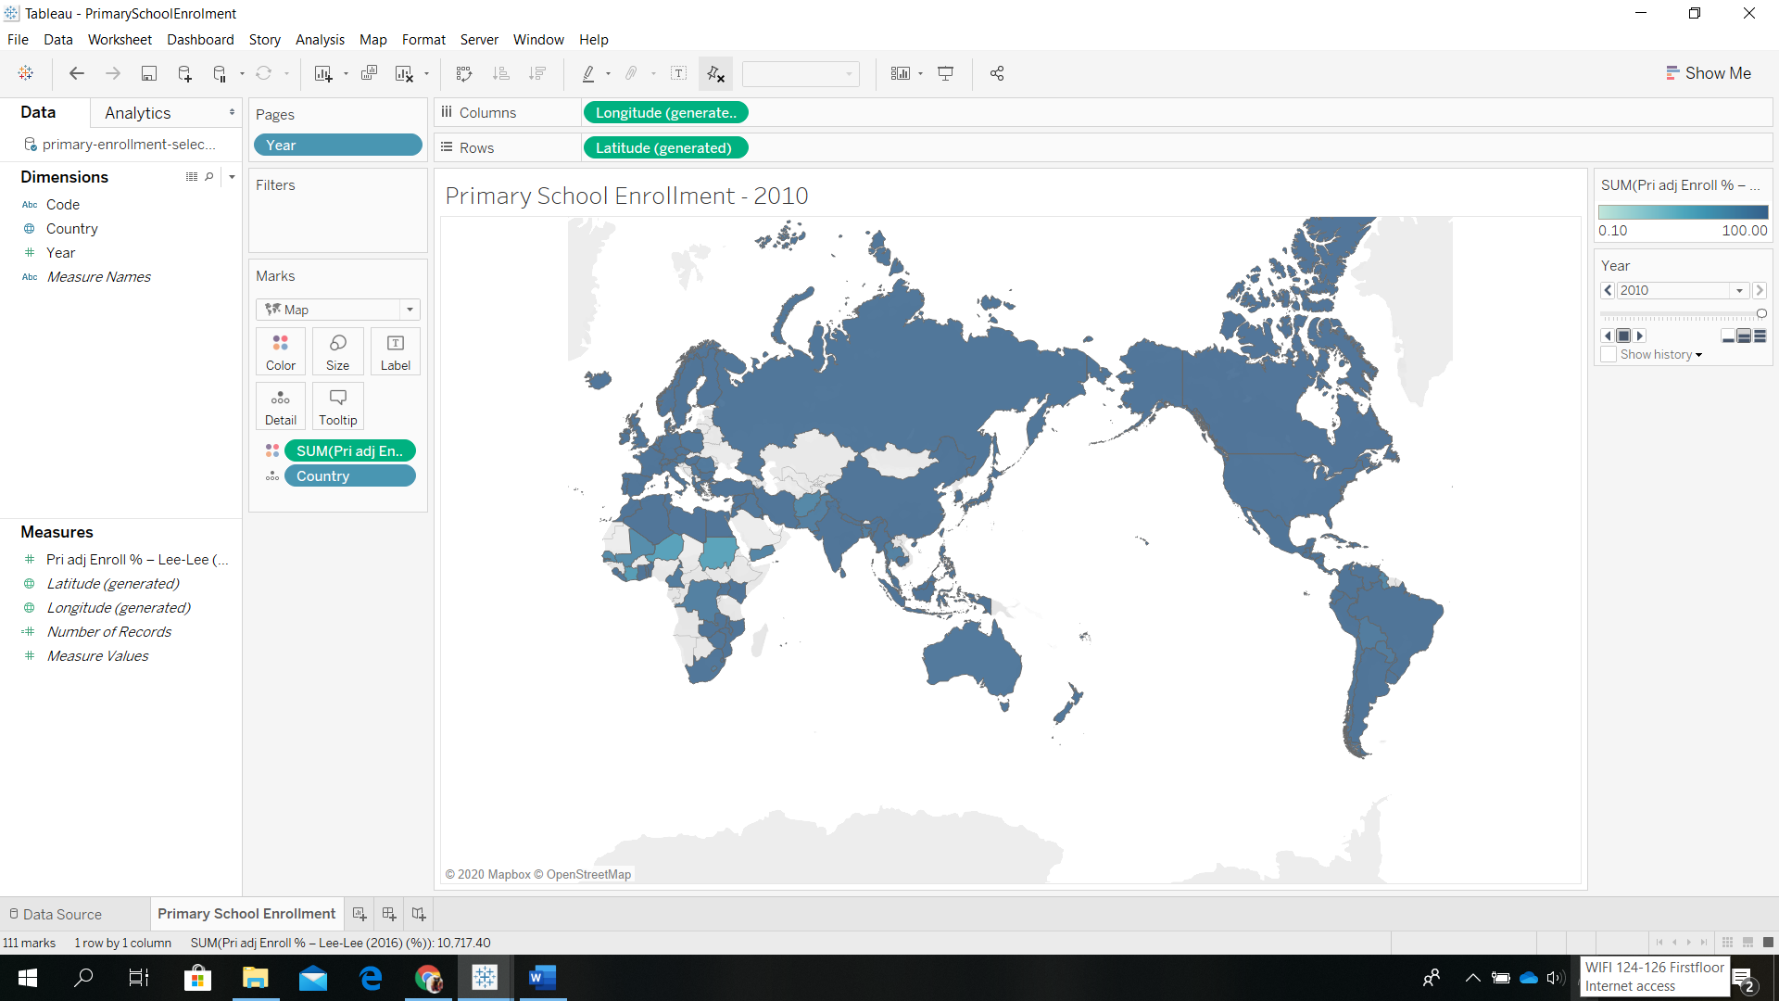

From the map we can see that there still are countries without any data. No matter how much we tried – we did not find anything. We can assume that they are not gathering data at all, or it is not outsourced anywhere.

But we still can make few insights our of this map. The amount of enrollments is still very low in Africa, Pakistan and Afghanistan, Thailand. What do these countries have in common? - Poverty.

## What should we do to change the situation?

We need to make the education affordable for EVERYONE.

We need to automate the enrollment process using robots or websites. (this way we prevent corruption).

Quick and free education for people older than 30. This will stimulate the population getting education and the amount of literate population will grow again.

Going away from grades at all. A grade became something pressuring for a student, so student’s mental health suffers. There is an instant competition between students and the education is left aside. Going from the grades to feedback might change the situation.